Module 7: Kubernetes
Assignment – 1
Tasks To Be Performed:
1. Deploy a Kubernetes cluster for 3 nodes
2. Create a NGINX deployment of 3 replicas

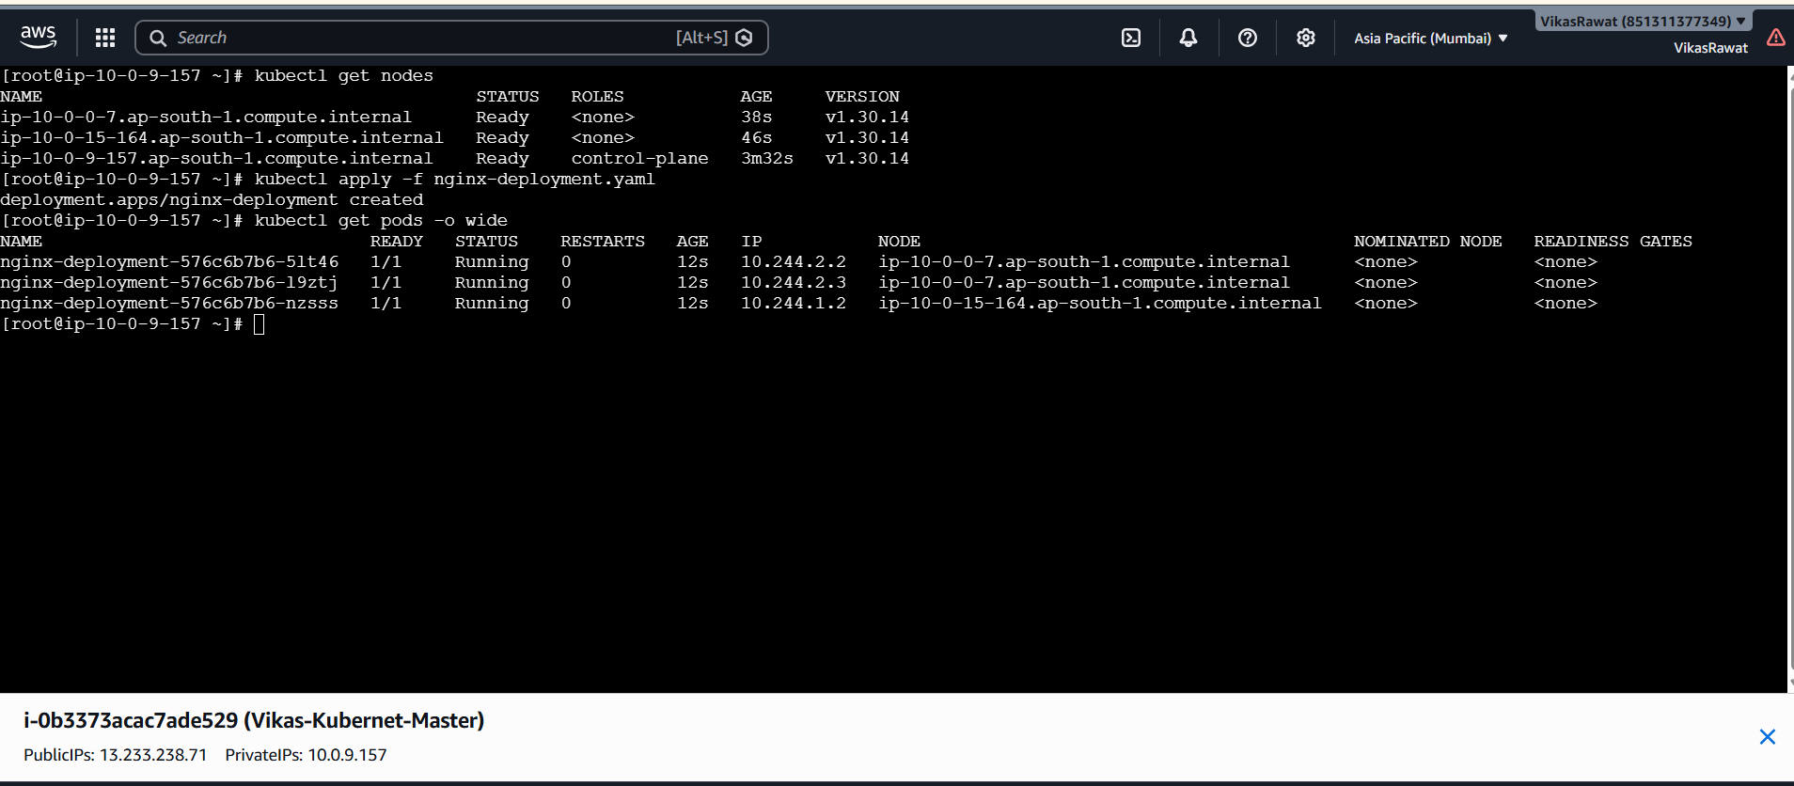

[root@ip-10-0-9-157 ~]# cat nginx-deployment.yaml
apiVersion: apps/v1
kind: Deployment
metadata:
name: nginx-deployment
labels:
app: nginx
spec:
replicas: 3
selector:
matchLabels:
app: nginx
template:
metadata:
labels:
app: nginx
spec:
containers:
- name: nginx
image: nginx:latest
ports:
- containerPort: 80

